*1. Report a good choice for single-parameter likelihood for the number of cars you sell in one day (xi), and an informative conjugate prior for the parameter.*

A good choice for single-parameter likelihood for the number of cars I sell in one day (xi) is **Poisson likelihood**, which indicates a discrete probability distribution that expresses the probability of a given number of events occurring in a fixed interval of time.

$$x_{i}\sim Poisson\left(θ\right), λ=1$$

An informative conjugate prior for the parameter would be a Gamma Prior,

$$θ\sim Gamma(α,β)$$

, whose variance $σ^{2}=\frac{α}{β^{2}}$, mean $μ=\frac{α}{β}$

To make the variance =1, and mean=1 because of our primary estimate of 1 car/day, we can get α=1, β=1.

Consequently, the prior is $$θ\sim Gamma(1,1)$$

, which is an informative prior as ∫g(θ)dθ<∞ as required.

*2. After one week, you sell 4 cars. Report the posterior distribution of your parameter.*

When we evaluate from a time interval of one week, which is 5 days, according to the summation property of gamma distribution[1], we have the 5-day prior

$$θ\sim Gamma(5,1)$$

Because $y=\sum_{i=1}^{5}{x_{i}}=4$, according to the property “Sum of independent Poisson random variables is Poisson”, [2]we know for one week, total car sales number y

$$y=\sum{x_{i}}\sim \sum{Poisson\left(θ\right)},λ=5$$

Thus, for the conjugate gamma prior and Poisson likelihood, we have posterior in weekly view:

$$π\left(θ | y\right)\sim Gamma\left(y_{1}+5,n\right)=Gamma(9,2)$$

*3. Use the posterior predictive distribution to calculate (or simulate) the probability that you will match or exceed Ronald Aylmer’s 2-week performance. Report this probability (rounded to nearest percent). Assume that your ability to sell cars remains constant throughout your employment.*

In order to match or exceed Ronald Aylmer’s 2-week performance, which is 10 cars in 2 week, I have to sell no less than 10-4=6 cars in week 2, which means y2>=6|y1=4.

The Posterior Predictive Distribution is:

$$p\left(y_{2} | y^{n}\right)=\int{p\left(y_{2} | θ\right)p\left(θ | y^{n}\right)dθ}=\int{\frac{{\left(5λ\right)}^{y}}{y!}e^{-5λ}\frac{β^{α}}{Γ\left(α\right)}λ^{α-1}e^{-βλ}dλ}$$

$$=\frac{5^{y}}{y!}\frac{β^{α}}{Γ\left(α\right)}\int{λ^{y+α-1}e^{-(β+5)λ}dλ}$$

$$=\frac{1}{y!}\frac{Γ\left(y+α\right)}{Γ\left(α\right)}{(\frac{5}{β+5})}^{y}{(\frac{β}{β+5})}^{α}=Negative-Binomial(y;r=α,p=\frac{5}{β+5})$$

Where, $p\left(y_{2} | θ\right)\sim Poisson\left(θ\right)$ and $p\left(θ | y^{n}\right)\sim Gamma(9,2)$, α=9,β=2. And

Let $g\left(θ\right)=1(θ≥6)$, according to the Law of Large Numbers,

$$\frac{1}{s}\sum_{i=1}^{s}{1(θi≥6)}→E\left[1\left(θ≥6\right) | y^{n}\right]=P(θ≥6|y^{n})$$

The empirical distribution of $\left\{θ1,θ2,…,θi\right\}→p(θ|y^{n})$

Consequently, using Monte Carlo Simulation, we first generate y(i) using rgamma function in R, then compute the g(y(i)), and finally use the expectation of g(y(i) to calculate the probability of y2>=6.

When S=100, p=12%;

When S=1000, p=18.3%

When S=10000, p=15.71%

When S=100000, p=15.393%

When S=500000, p=15.4178%

When S=1000000, p= 15.5311%

Consequently, we get the final result of **a probability 15%** to match or exceed Ronald’s 2-week performance.

In fact, I also calculated the theoretical probability of the question, which can be acquired through the integral $\int{g\left(θ\right)p\left(θ | y^{n}\right)dθ}$, and the result is 15.5027%.

*4. What is the probability that your bonus after your second week of work, b2, will exceed $100, given that you sold 4 cars in week 1? Report this to the nearest percent. Plot the distribution of b2 as a histogram, not a density.*

Given the fact that I sold 4 cars in week 1, I have a posterior of $Gamma(9,2)$, which is the same as in problem 3.

In order that

$$b_{2}={(2πy_{2})}^{\sqrt{2}}>100$$

There has to be a y with $y_{2}>\frac{{100}^{1/{\sqrt{}}}2}{2π}≈4.13$. Because y has to be integer, y2>=5. The result is shown in the following histogram and the corresponding probability of getting >100 bonus is 33%.

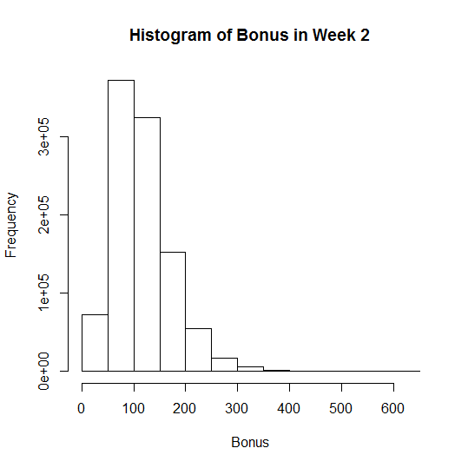

##################Code######################

######problem 3###########

theta=seq(0,10,length=11);alpha=9;beta=2;S=1000000;

posterior <- dgamma(theta,alpha,beta)

expectation <- function(x){

z=dgamma(x,9,2)*as.numeric(x>=6)

return (z)

}

theoretical=integrate(expectation,lower=0,upper=Inf)

expectation <- sum(as.numeric(rgamma(S,alpha,beta)>=6))/S

print(expectation)

#######Problem 4############

threshold <- ceiling(100^(1/sqrt(2))/(2*pi))

temp <- rgamma(S,alpha,beta)

expectation2 <- sum(as.numeric(temp>=threshold))/S

print(expectation2)

hist((2*pi*temp)^(sqrt(2)),breaks=10,xlab="Bonus",main="Histogram of Bonus in Week 2")

1. http://en.wikipedia.org/wiki/Gamma_distribution#Summation
2. http://www.proofwiki.org/wiki/Sum_of_independent_Poisson_random_variables_is_Poisson